CT60A5103 Software Engineering Models and Modeling
Final project
Case: AudioNow

Hyechan Shin
Robert Gabrielsson

Introduction
We chose the AudioNow as a main project case and selected the Incremental Model for our software engineering process model. As client is expecting to this project to be completed within 12 months, with the incremental approach, the product is being added piece by piece, allow us to see the results each month. This will help us to focus on where to allocate resources more effectively and efficiently throughout the project.
This report builds on our Topic 2–5 assignments. We reuse the process model from Topic 2 and the use case diagram, domain model, BCE diagram and collaboration diagram from Topics 4 and 5. We expanded them to cover the whole AudioNow system and fixed the places where they did not match, so the same names are used in every diagram.

Use Case Diagram
Figure 1 (next page) shows the actors and the main use cases of AudioNow. The grey box is the system boundary. The yellow ovals are the twelve main use cases. The white ovals are supporting use cases that several main use cases reuse through «include» or «extend» (Rosenberg & Stephens, 2007).
The actors on the left use the system. Guest, Listener, Subscriber and Migrated Customer are linked by generalization: a Listener can do everything a Guest can, and a Subscriber or a Migrated Customer can do everything a Listener can. This matches the four user groups in the case. Creator publishes podcasts. Content Manager, Advertisement Department and Administrator are MediaFun staff.
The actors on the right are external systems. Payment Provider approves payments. Billing System receives every transaction for the accounting department. Order Management System tells us if an item is in stock and receives orders for physical items. The Legacy E-commerce Database is used when an old customer activates their moved account.
Play Advertisement extends Listen to Podcast and Watch Promotional Show. It only runs when the user has no active subscription. This covers the rule that guests, free users and old customers hear ads.
Changes from Topic 4: we expanded the diagram from one use case to the whole system. Set Subscription Plans moved from Creator to Administrator, because the case says MediaFun manages the subscription plans. Pay for Subscription became a general Pay use case, since subscriptions, merchandise and tips all use it. Browse Podcasts is now part of Listen to Podcast.
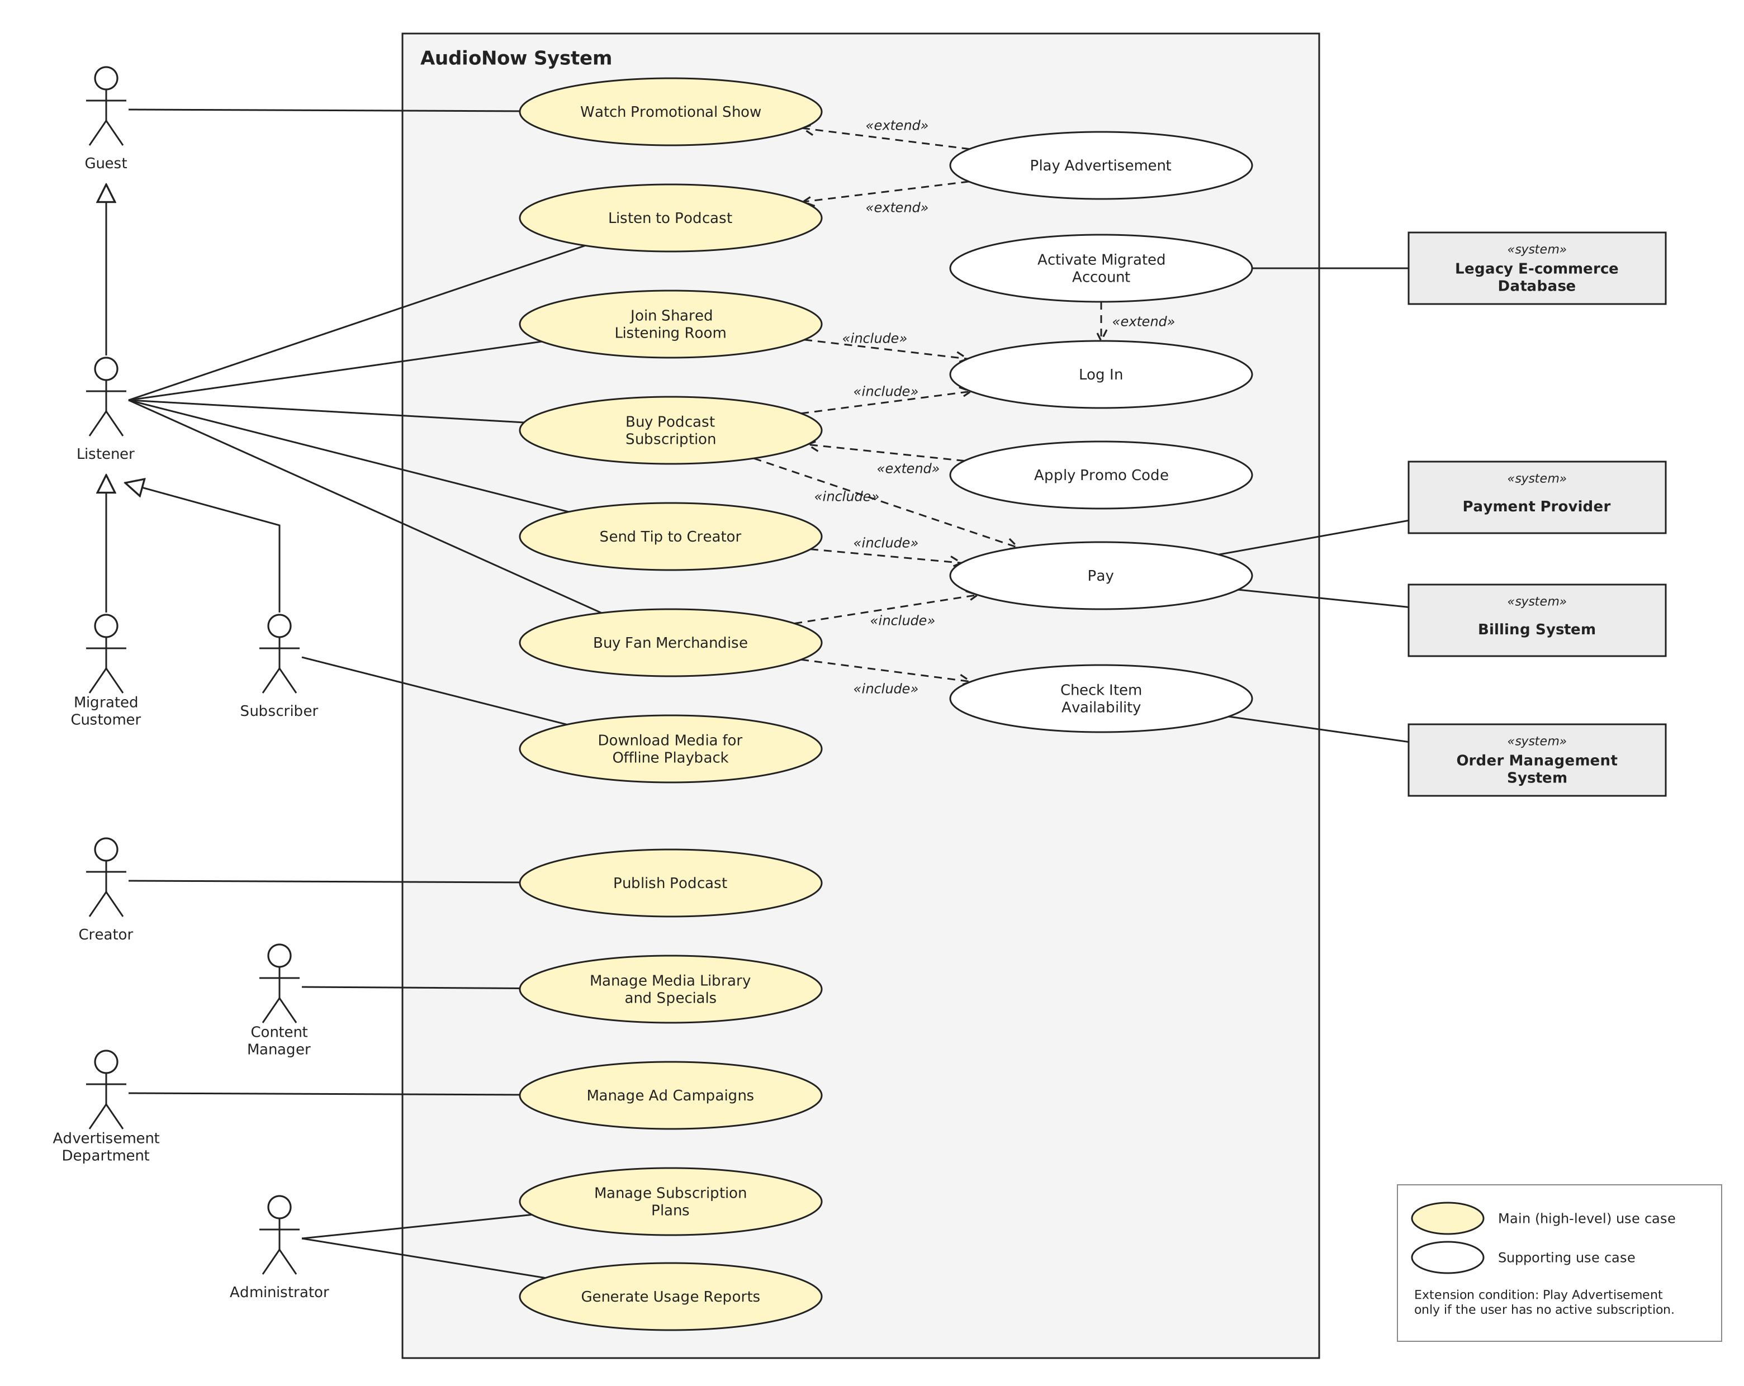
Figure 1. Use case diagram of the AudioNow system.

Domain Model
Figure 2 is the domain model of AudioNow (Fowler, 2004). The green classes come from our Topic 4 model. The grey Item class is not stored by AudioNow: its data lives in the MediaFun warehouse database and is read through the order management system.
UserAccount is an abstract class with the shared login data. Listener and Creator inherit from it. Listener has isMigrated and legacyCustomerId, so an old e-commerce customer can be linked to their new account. AdProfile holds the profiling data that the advertisement system uses to choose ads.
One SubscriptionPlan (for example 10 € per month) covers all podcasts, as the case describes. A Subscription follows one plan and can use one PromoCode. Payment is shared: a subscription, an order and a tip are all paid by a Payment, which is then sent to the billing system.
ListeningRecord stores every playback. This is the data for the legal reports on what media was played and how many times. Download stores offline copies and their licence expiry, so the system can check that only paying users keep offline media. ListeningRoom stores the shared listening rooms: one Listener hosts a room and many Listeners can join it.
Item has the attributes listed in the case: ID, name, short description, availability, amount in stock, price in EUR, and a list of related items (the related to self-association).
Changes from Topic 4: in Topic 4 each Podcast had its own SubscriptionPlan. We removed this link, because the case says one subscription gives access to any podcast. Podcast now has an accessLevel attribute (free or premium) instead. We also added attributes and the classes needed by the other use cases.
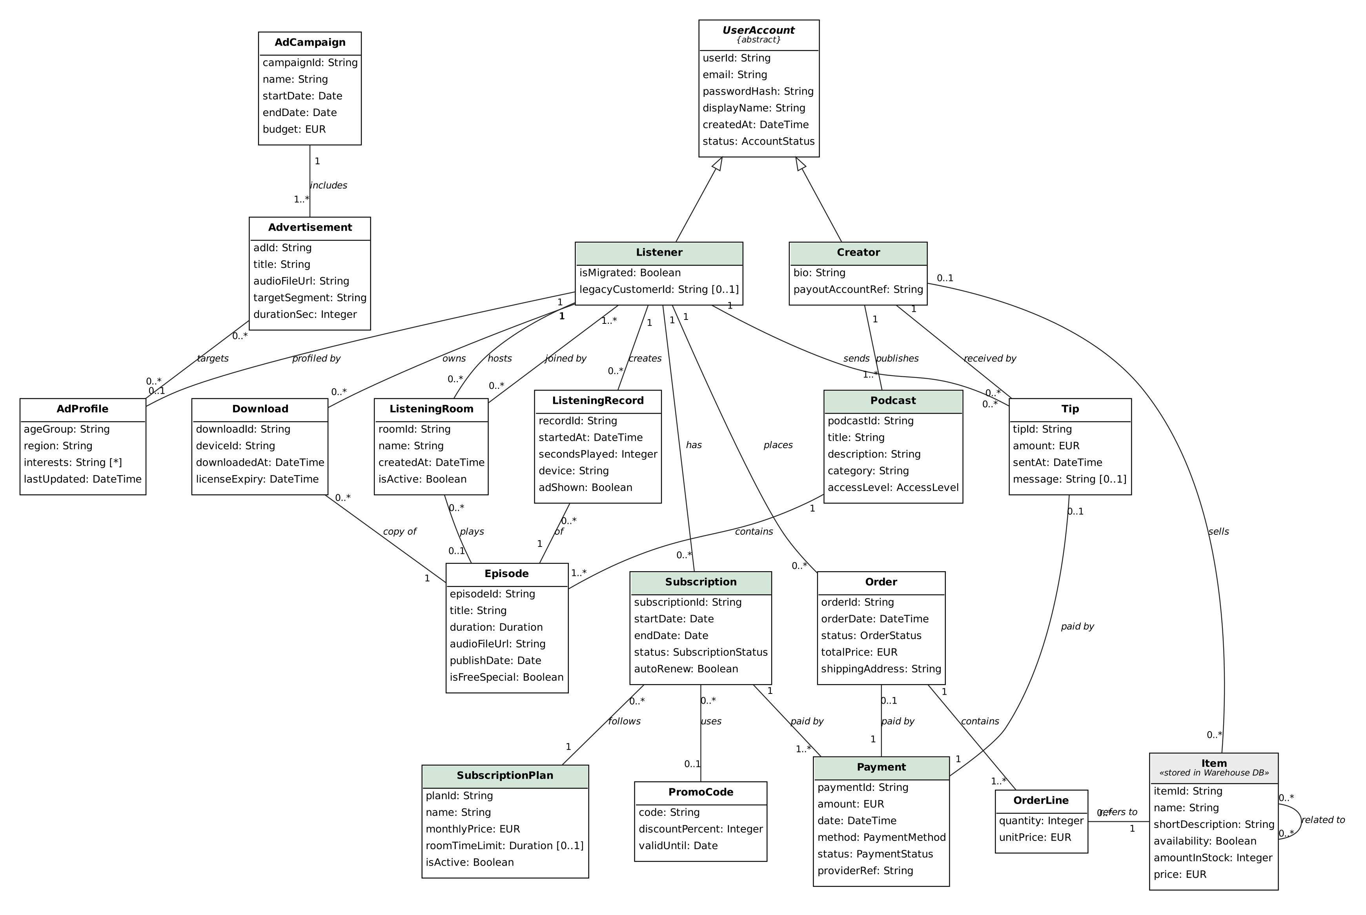
Figure 2. Domain model of AudioNow as one class diagram.

Deployment Diagram
Text

MVC or BCE model
Figure 3 is the revised BCE diagram for Buy Podcast Subscription. Boundary objects are screens and interfaces to external systems, control objects are actions, and entity objects come from the domain model (Rosenberg & Stephens, 2007). The numbers match the use case steps.
The Listener opens the Podcast Page (1). Show Plans reads the active SubscriptionPlan and opens the Checkout Page (2–3). The Listener enters the payment details (4). If a promo code is entered, Validate Promo Code checks it (4a). Process Payment sends the payment to the payment provider through the Payment Gateway Interface and saves the Payment (5). If the payment is declined, the Checkout Page shows an error (5a). Create Subscription saves the Subscription and updates the Listener, so ads are turned off (6). Sync Billing sends the transaction to the billing system (7). Finally, the Confirmation Page is shown (8).
Changes from Topic 4: entity names now match the domain model. Process Gateway was renamed Payment Gateway Interface. We added Validate Promo Code, the declined-payment path and Sync Billing, because the case requires that transactions are forwarded to the billing system.
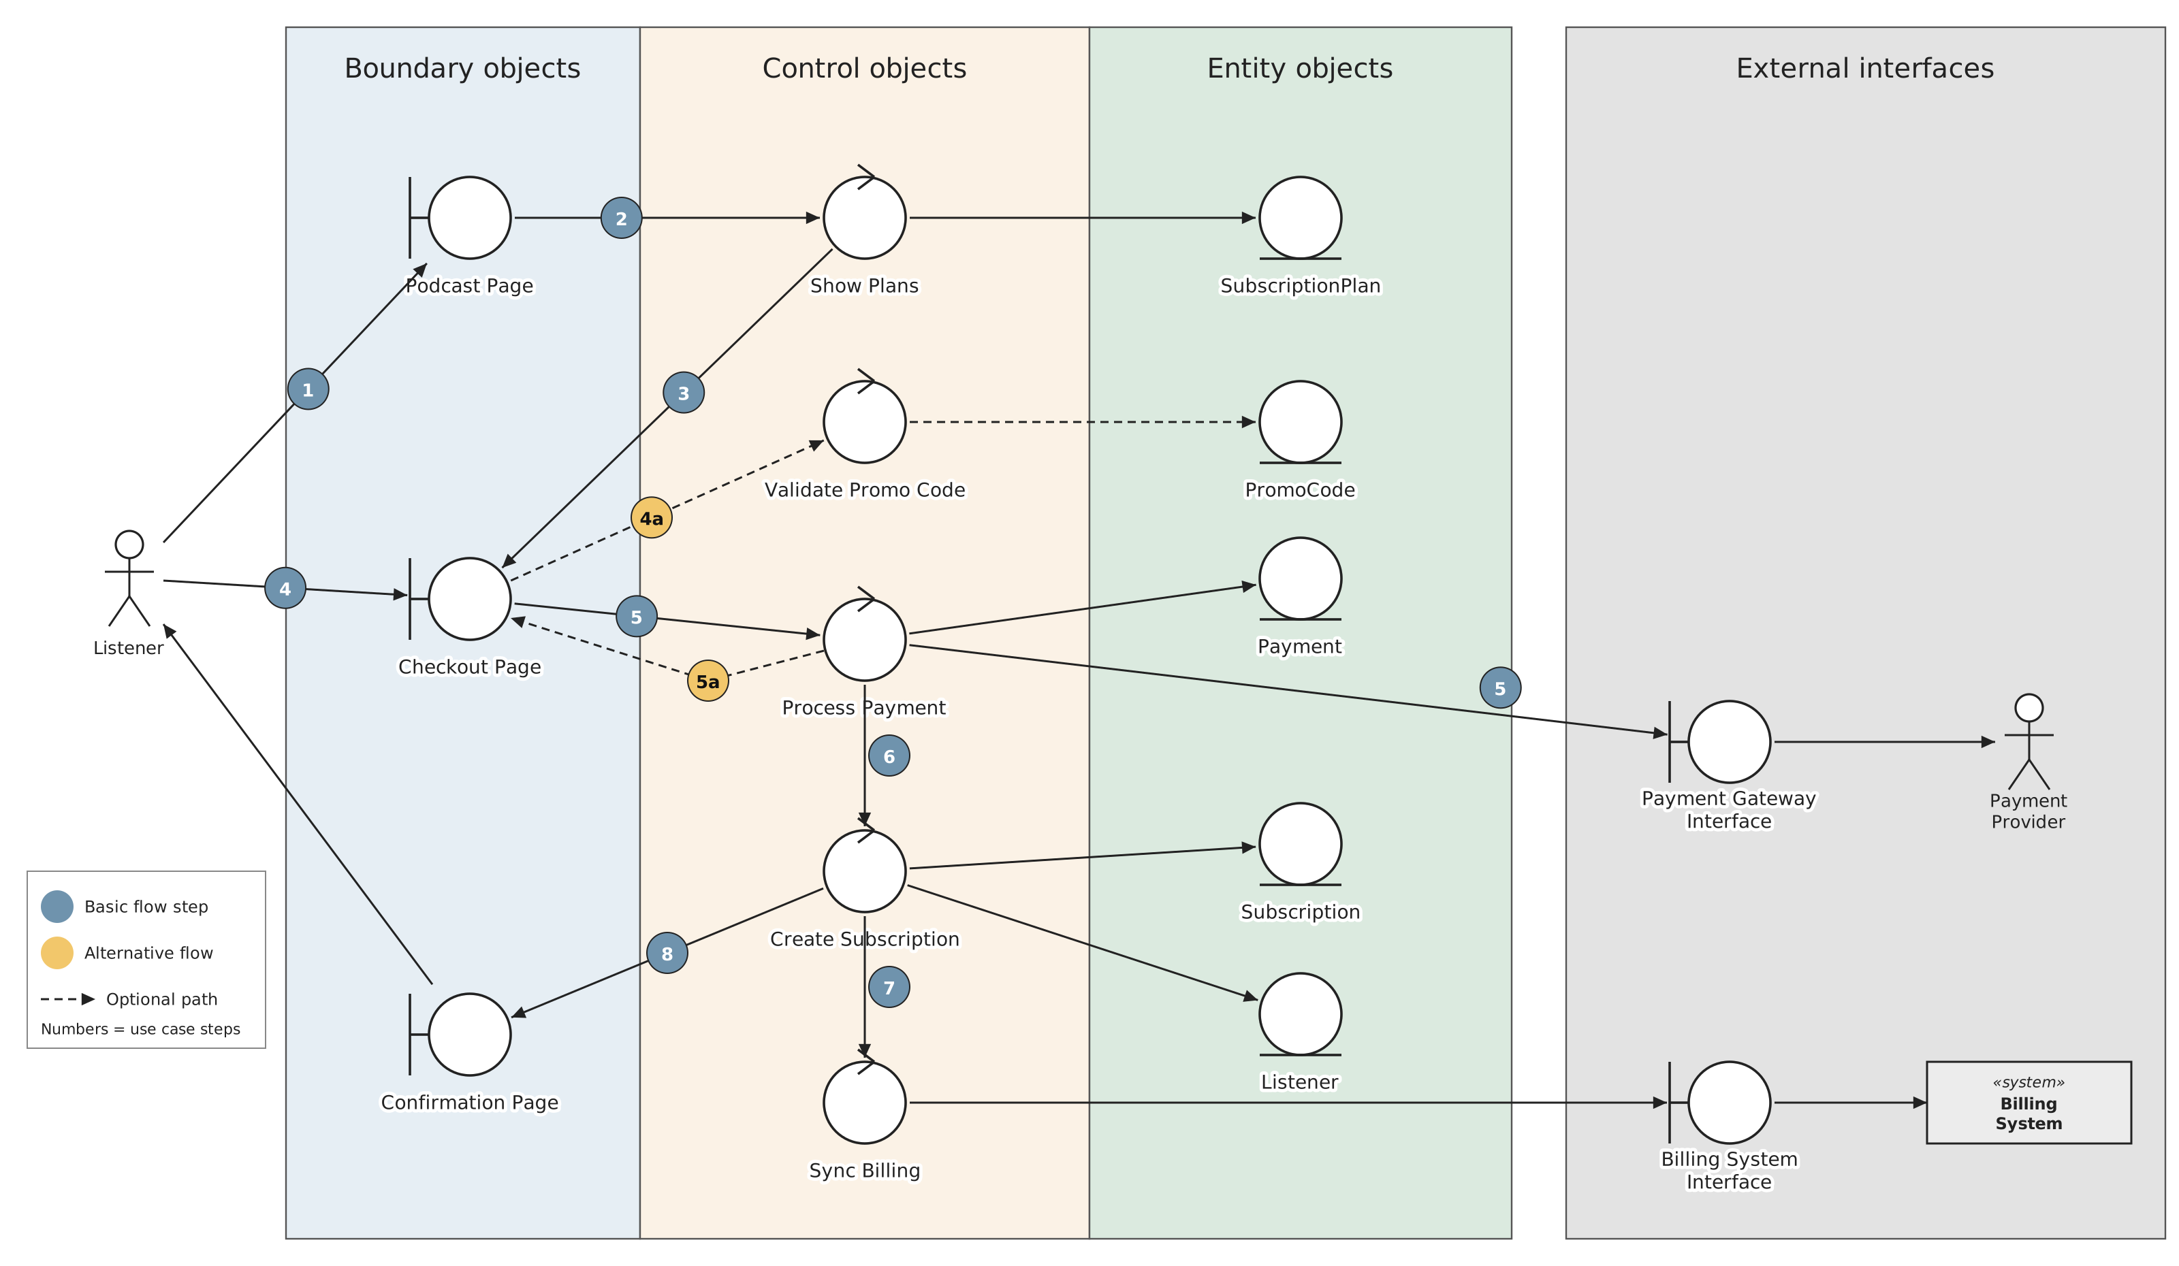
Figure 3. BCE (robustness) diagram for Buy Podcast Subscription.

Activity and communication diagrams
Figure 4 turns the BCE diagram into a UML communication diagram. The objects and links are the same as in Figure 3. Each message has a sequence number, a name and its parameters, and a small arrow shows its direction (Fowler, 2004).
Guard conditions show the alternative flows. Message 6 only happens when a promo code is entered. After the payment provider answers (10), message 12 [declined] sends the Listener back to the checkout page with an error, and message 13 [approved] continues to create the subscription.
Changes from Topic 5: we use the UML message format (number: name(parameters)) instead of free text, and we added the declined path and the billing sync (16–18).
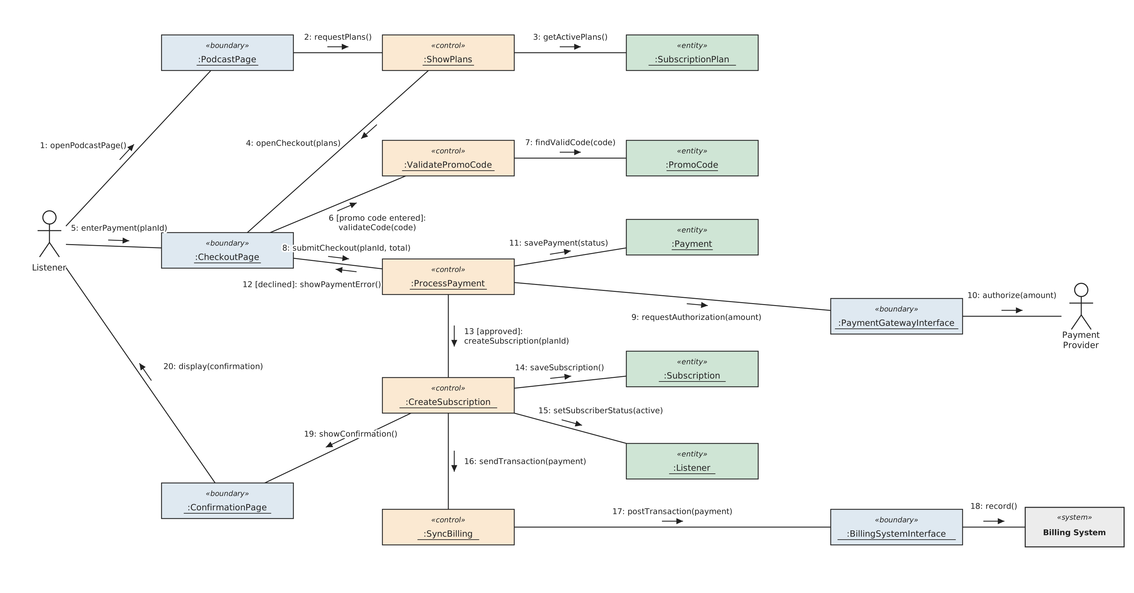
Figure 4. Communication diagram for Buy Podcast Subscription.

Risk modelling
Text

Alpha project plan and schedule
Text

Pitching deck
Text

Execution of work and clarity
Text

Clarification of AI Usage
Claude (Anthropic) was used to check the diagrams from Topics 2–5 against each other and against the case, and to redraw and expand the use case diagram, domain model, BCE diagram and communication diagram. The team reviewed and edited the results.

Reference
GeeksforGeeks. (2020, September 17). Difference between Spiral model and Incremental model. GeeksforGeeks. https://www.geeksforgeeks.org/software-engineering/difference-between-spiral-model-and-incremental-model/
Fowler, M. (2004). UML distilled: A brief guide to the standard object modeling language (3rd ed.). Addison-Wesley.
Rosenberg, D., & Stephens, M. (2007). Use case driven object modeling with UML: Theory and practice. Apress. https://doi.org/10.1007/978-1-4302-0369-8

---Assignment descriptions---

General requirements

Max 2 pages (+1 cover page). Please concentrate on designing a good process model, explaining it, and detailing the deliverables listed below at a general level. When designing, think about why the case company (see full project assignment) needs it and its relationship to the project.

Submit this assignment via Moodle as PDF (see the exercises and assignment page for the return link)

If accepted, you may revise and include this deliverable as part of the final version of the course project report.

Assignment introduction and motivation

Some companies have technical or artistic talent, but they are unfamiliar with how to organize for software engineering and how to set up their software engineering process. In this case, imagine yourself as consultants who help the company described below to set up and customize a software engineering process for their use.

In the case described below, you are consultants hired by the case company to help design a process that meets design requirements.

Case description

In this case, you and your team are a new software consultancy and has just received their first project assignment, or the course project case. During the bidding process, your client requests the following information and schedules.

· A proof-of-concept demo and full design documentation before the approval of further development work. Design can be modified during the development based on the feedback.

· A test plan for quality assurance including testing with the real target audience users

· Monthly reviews on progress, including review data from user testing

· Proof that the work is actually supervised, and that there is management of daily tasks

· The project has to be completed in 12 months, of which 1 month has to be reserved for quality assurance and acceptance testing only.

· Client pays for reasonable amount of working hours only and is not willing to pay salary for more than 10 people.

You can hire a maximum of 7 people, of which 3 are mainly developers and 3 mainly artists. The seventh person is mostly occupied by the sales and management tasks, but in reality currently everyone does a bit of everything. Your consultancy already has access to the necessary tools and object libraries and other assets to technically construct the product.

Case assignment

This is where your team is brought in. You task is to create a process model, deadlines, document specifications and internal schedule for the software consultancy to use and apply on their project. Define how the development work should be done, what metrics should be collected, what things should be tested (and how they should be tested), and what things has to be documented. Draw a process model diagram, define internal deadlines for each phase, and define the necessary documents on the “table of content”-level. Also explain why you chose those particular ways to do the work.

Deliverables

Write a short document that describes a software engineering process model that your team has planned. Minimally, include following in the process document.

The software engineering process model and the rationale for selecting it (see course literature)
What steps are in the process model, what deadlines are in the process (internal schedule), and what things are documented each step.
Briefly describe each document or artefact that is outputted (e.g. design or QA document). Do not describe actual content, but describe the rough structure and its purpose.
Testing and metrics - where do they occur and how they are reported by a) developers to consultancy and b) consultancy to client?
For other components to include in the assignment, read the case assignment and case description carefully. The client company requires several documents and artefacts from your consultancy.

Return the group work via course Moodle page with the document as one pdf file, including the PDF file. If you are experiencing problems, please contact the course lecturer.

Q&A
In this part, we have collected some questions previously asked by students.

Q: I am unsure how to get started.
A: Review Sommerville on software process models and how Sommerville's coursebook and slides have pictured software process models. The first part of topic 2 lectures (Sommerville on fundamental software engineering activities) is also a good part to start watching.

Q: What is a software process model diagram?
A: In this assignment, you do not have to use any specific modeling language. Have a look at the visual examples and then create your own.

Q: Do I need to design the software product itself or for example draw prototype visuals?
A: No. Just describe what is the purpose of the prototype and what content a prototype should have.

